Lab 1: Preparation

# Question 2

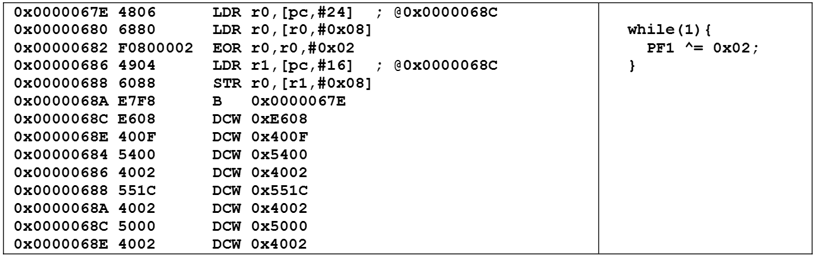

**What is the purpose of all the DCW statements?**

The purpose of the DCW statements is to allocate a 4 bytes of data into that memory location. This is an assembler directive that stores the data before the program is run. Padding is added by ensure memory alignment. In this example, the DCW statements are used to store the address of PF1 in memory so that the program can access it with offsets.

**How fast will PF1 toggle?**

It takes 25ns to execute an instruction (on average), and the main loop has 6 instructions, so it takes 25*6 = 150ns to toggle.

**What is in R0 after the first LDR? What is in R0 after the second LDR?**

R0 will have 0x4002500 after the first LDR, which is the address of PF1 for bit-specific addressing. R0 will have the current value of PF1 after the second LDR.

**How would you have written the compiler to remove an instruction?**

Two of the LDR instructions are loading the same thing (0x4002500 – the address of PF1). The second one can be removed if the first one (in R0) was not overwritten by the value of PF1. The compiler could have used a different register to store the value of PF1 so that R0 can be used directly for the STR instruction.

**Is there a critical section?**

There is not a critical section between the main function and the ISR because they are using bit-specific addressing. The ISR only read-modify-writes to PF2, while main does the same to PF1.